SPONSORSHIP OPPORTUNITIES

□ $125 Tee Sign
□ $200 Flag
□ $400 SINGLE GOLFER
□ $500 Closest to Pin Sponsor
□ $500 Longest Drive Sponsor
□ $500 Beverage Cart Sponsor
□ $500 Half-Way House Sponsor
□ $750 Driving Range Sponsor
□ $850 Golf Cart Sponsor
□ $1,000 Awards Sponsor
□ $1,500 FOURSOME: includes Golfing with a
Celebrity and a Tee Sign
□ $1,500 Towel Sponsor
□ $1,500 Athlete Sponsor
- Includes Foursome
□ $2,000 Golf Shirt Sponsor
□ $2,500 Lunch Sponsor
□ $5,000 Dinner Sponsor
□ $7,500 Outing Sponsor
□ $10,000 Major Sponsor
□ Prize or Raffle Donation
□ 50/50 Raffle Tickets
- $50 Each or 3 for $100

________________________________
Company Name

__________________________________
Address

__________________________________
City State Zip

__________________________________
Phone

____________________________________
Email
GOLF COMMITTEE
Frank Tepedino Tom Sabellico
Frank Borracci Fred Cambria Deborah Nocerino Canova James Cahill Armando D’Accordo Don DeMola
Ralph Fusco Dan Kornfeld
James Martin Jim Meyer
Pat O’Brien John Pennisi
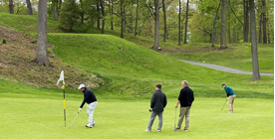

Firefighters Charitable Foundation
1 West Street
Farmingdale, NY 11735
(516) 249-0332
Email: ffcf@ffcf.org

Visit www.ffcf.org for more information.

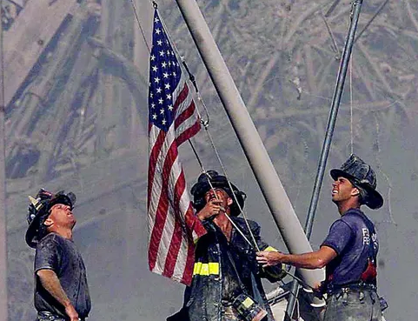

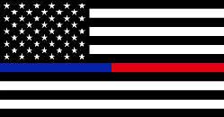

Firefighters Charitable
Foundation
Celebrity Golf Tournament

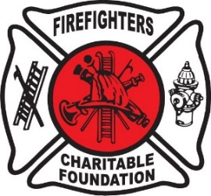

Monday, April 20, 2026
Town of Oyster Bay Golf Course 1 South Woods Rd.
Woodbury, NY

2026 Golf Outing Honoree
Robert (Bob) Seidel in Memoriam
Outing Sponsored by his daughter Janine Campbell

WAYS YOU CAN SUPPORT
WAYS YOU CAN SUPPORT
OUR CAUSE:
Sign up for a day of Golfing and Dinner to follow!
- Join us for dinner (no golfing neccessary)
- Become a Sponsor
- Donate Raffle Prizes

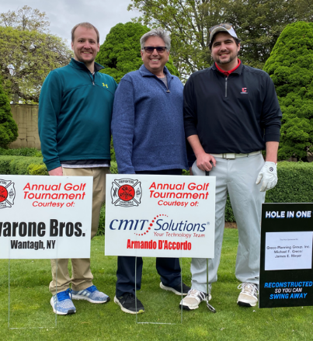

OUTING SCHEDULE
10:30 am Registration, Coffee, etc.
10:30 am Driving Range Opens
11:15 am Intro of Athletes
Reading of Rules
11:30 am Shotgun Start, Hamburgers, Hot Dogs, Chicken and Beverages
On Course
4:30 pm Cocktail Hour
5:30 pm Dinner, Raffles and Awards

ATHLETES INVITED TO APPEAR!
Maxcine Agee Vito Antuofermo
Tony Balsamo Erik Burgdoerfer
Fred Cambria Frank Catalanotto
Don DeMola Jason Grilli
Steve Grilli John Halama
Dave Lemanczyk Paul Mirabella
Ray Negron Billy Sample
Rick Schmidt Art Shamsky
Judy Sladky Frank Tepedino
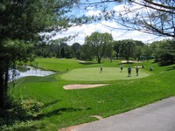
Golf Fees include:
18 Holes of Golf Golf Cart
Bag Drop Lunch
Balls/Tees Dinner
Snacks and drinks on the course!
Continental Breakfast!
Golfing with a celebrity!
Dinner Only
____________@$150 per person
(Please indicate number of people.)

Email _____________________________

The Town of Oyster Bay Golf Course is located at 1 South Woods Road, Woodbury, NY 11797
(Tel. 516-677-5960)
TOURNAMENT ENTRY FORM
($400 per person/$1,500 per foursome)
Foursome Price includes Golfing with a Celebrity and a Tee Sign
Entries will be accepted as individuals, two, three or four person groups.

Golfer #1
Name___________________________________

Address ________________________________

City, State ______________________________

Tel. # __________________________________

Email __________________________________

Golfer #2
Name___________________________________

Address ________________________________

City, State ______________________________

Tel. # __________________________________

Email __________________________________

Golfer #3
Name___________________________________

Address ________________________________

City, State ______________________________

Tel. # __________________________________

Email __________________________________

Golfer #4
Name__________________________________

Address ________________________________

City, State ______________________________

Tel. # __________________________________

Email __________________________________

